Risk & Control Framework
CadaWada Ltd
London, UK
October 2021

Introduction
As with many modern financial institutions heavily reliant on technology, CadaWada faces several risks from the overall business operation perspectives. As such, CadaWada will employ a Risk Based Approach (RBA) to all its operations globally. The risk-based approach will enable CadaWada identify all risks associated with the business using a risk framework, then apply controls and mitigations to ensure the business can deliver its services whilst remaining compliant and secure.

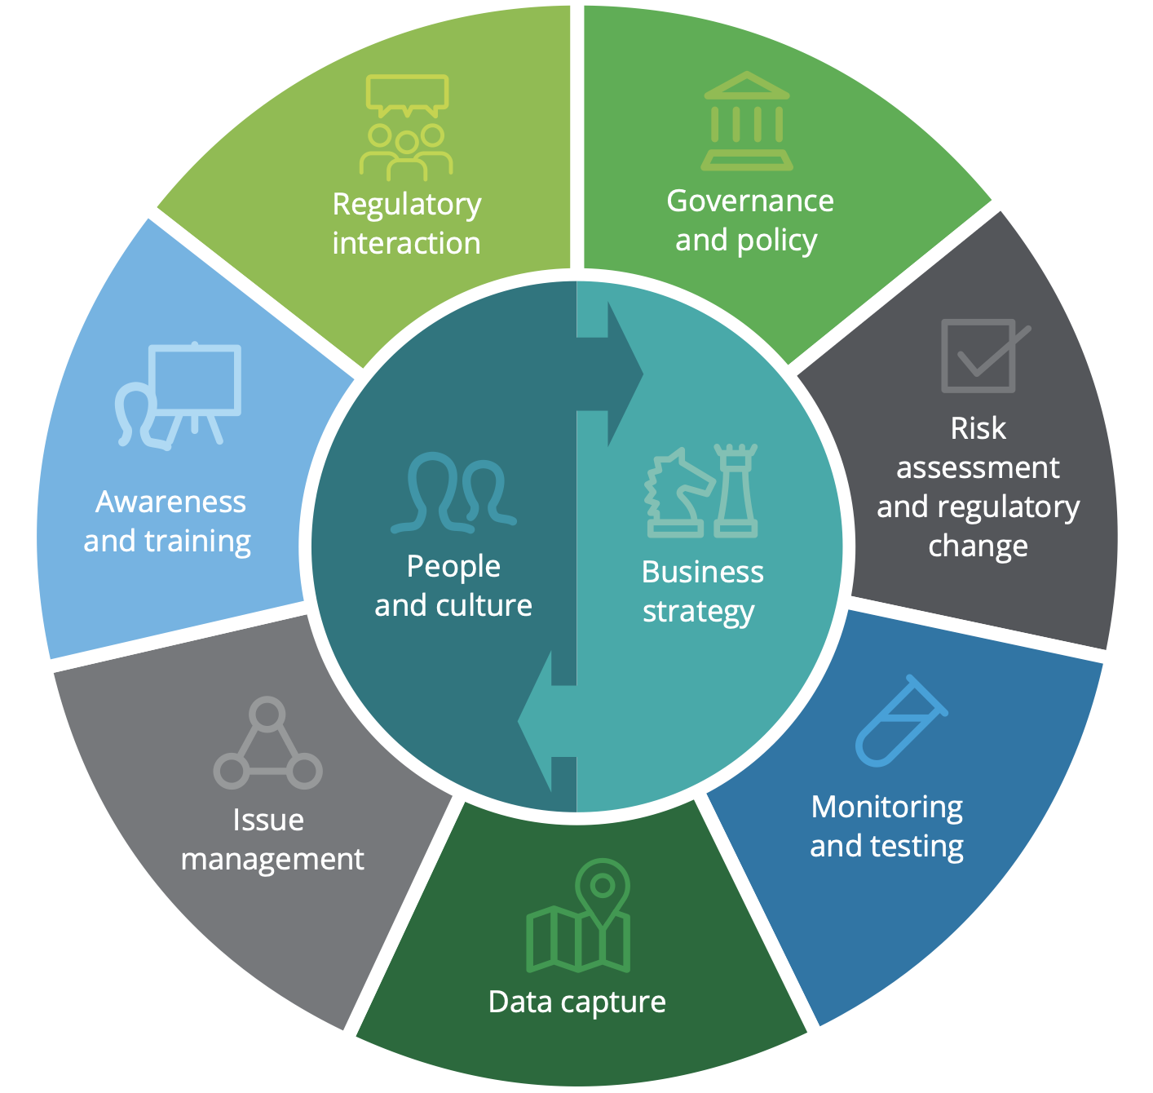
Fig 1: CadaWada will adopt the Deloitte Risk & Compliance program framework
Figure 1 portrays a risk and compliance program framework derived from regulatory expectations that consists of capabilities responsive to the inherent risk of the operating business. The CadaWada Risk assessment framework is modelled against the Deloitte Risk & Compliance programme framework on Risk Based Approach for Money Services Business.

Categories of CadaWada Risks

We have identified some categories of risks faced by CadaWada.

- Operational risk: CadaWada is a platform that aims to delivery payment services to some high-risk financial regions. The platform is also heavily reliant on counterparty APIs, as such subject to operational risks. A combination of suboptimal internal processes and third-party supplier risk may lead to significant customer service failings and dissatisfaction. Operations in high-risk regions may require additional controls and fraud-prevention measures.

- Financial risk: Credit & Liquidity are essential to the growth and success of CadaWada. Poor liquidity can result in fines, unhappy customers, legal fees, lost business and missed opportunities.

- Regulatory & Compliance risk: CadaWada aims to eventually operate in a few jurisdictions. This comes with the tedious task of compliance with multiple regulatory bodies. Regulatory Compliance is therefore essential for CadaWada to remain operational and successful. Non-compliance can lead to sizeable financial losses from fines, severe penalties & sanctions, as well as reputational damages. CadaWada will comply with regulations including:

  - Anti-bribery and corruption
  - Anti-money laundering
  - Regulatory policy (PSD2, SCA)
  - Data protection Act & GDPR
  - Amongst others

- Reputational risk: CadaWada will rely on its exposure to build its customer base, therefore any public relation failings from poor customer services, fraud etc. can cause serious damage to brand equity.

- Product Risk: There are inherent risks associated with each product/service on offer, particularly FX Marketplace.

- Customer Risk: CadaWada will be exposed to some high-risk regions, therefore high-risk customers who may pose an increased risk due to their network, transaction type or volume.

- Geographic Risk: There will be significant volume of transactions to "high" risk geographic locations on CadaWada, although 95% of these would be outbound payments from the UK.

- Risk of Fraud & Financial Crime: The platform is greatly exposed to several types of fraud. Money Laundering, Unauthorised Account Access, Terrorism financing, Unauthorised transactions, Internal Fraud, Compromised employee.

- Cyber Security Risks: Hacking, Internal threats, DOS, Data Breaches, Phishing attacks are all possible risks faced by CadaWada. The company has a clear cybersecurity plan.

The purpose of this document is to enable CadaWada support various mission-critical tasks, including:

• Guiding company strategy;
• Raising broader awareness of key risks;
• Assessing potential risks and pitfalls;
• Identifying corporate governance gaps; and
• Testing remediated processes.
Train employees effectively

Risk & compliance framework
People and culture
The CadaWada risk and compliance management programme aligns with the company’s culture and is designed to meet regulatory and industry expectations. CadaWada culture empowers its people to effect proper risk management and achieve business objectives whilst remaining compliant. CadaWada will carefully select its management team and advisers with relevant industry experience and knowledge.
Business risk strategy
CadaWada Risk and compliance strategy are aligned to the overall business strategy, with risk management having a seat at board level. Risk management has a view and advises the business, management, and board on its strategy. CadaWada has a clear outline of the risks related to activities across all business units of the organisation, including a comprehensive identification and mapping of critical business processes, operational vulnerabilities and regulatory requirements. See risk assessment matrix for Risk scoring and ranking that promotes transparent and consistent prioritization process.
Governance and policy
CadaWada have clear and well-articulated governance, monitoring and compliance policies covering roles, responsibilities, and decision-making rights that support the risk culture and strategy. The governance model is designed to empower the organization and its committees to determine how much risk the company is willing to take, as in the case of money laundering and fraud risk, and at what transaction level threshold such risk is not sustainable or desirable for the company to do business. The compliance governance policy establishes minimum standards and guidelines for committee activities, including the development of committee charters and templates for meeting agendas. This policy allows for efficient committee oversight for identified risks by establishing and monitoring the organization’s risk appetite. See Governance Policy Document.
Risk assessment and regulatory change
CadaWada has identified risks associated with its operations, counterparties, service delivery and defined mitigating control measures as well as implementation plans. CadaWada has a clear understanding of all its regulatory obligations and has actively implemented measures within its product to ensure excellent customer experience. There is a clear change management framework from software product version control to business strategy and compliance with regulatory changes. CadaWada has employed a risk and control self-assessment (RCSA) methodology that allows the business to determine the current state of its control environment by evaluating existing controls for design and operational effectiveness. The RCSA process has helped CadaWada identify control vulnerabilities and missing controls and provide the opportunity for the business to evaluate whether a control should be created or if the residual risk can be mitigated by other existing controls or accepted as part of their overall risk appetite thresholds. Refer to the Risk assessment section of this document.

Monitoring and testing
CadaWada has established a control testing and monitoring program for at minimum high-risk activities with applicable reporting of risks and issues. Further development and implementation of key performance indicators (KPIs) and key risk indicators (KRIs) are monitored with defined thresholds. Refer to Compliance and monitoring policy. In addition, there is a comprehensive platform software audit policy that requires an annual third-party penetration testing of the platform to ensure it meets all cyber security standards required to deliver financial services.
Data capture
CadaWada will capture multiple types of data in order to deliver services to its customers. Consistent data capture in line with CadaWada privacy policy will facilitate data analysis, measurement, and reporting for strategic decision making by the management and board. CadaWada will collect some data explicitly provided by customers via mobile app or website, such as Name, date of birth, telephone number, email address, home address, photo ID, credit card & bank details as well as any other information required to fulfil its services. CadaWada will also collect additional data not explicitly provided by the customer. Such data is required to secure the user and platform, monitor traffic and/or make decisions. These include IP address, device information, Geolocation data, user behaviours, transaction history amongst others. Refer to privacy policy.
Issue management
CadaWada has a clearly defined complaints reporting and issues management policies. Issues decisioned at various levels, including the business, risk management, executive management, and board, are identified, escalated, and remediated. CadaWada focuses on the early identification and resolution of issues. CadaWada has defined comprehensive issue management policies including customer complaints policy and incident reporting policies.
Awareness and training
CadaWada will prioritise employee training across all business units. The training program includes AML/KYC training, compliance, risk management, customer services, cybersecurity, and other related training programmes applicable across the business.
Regulatory interaction & Reporting
CadaWada has defined a comprehensive communications policy that covers Internal communications and regulatory reporting to the Financial Conduct Authority (FCA). Regulatory reporting is a key consideration through-out the development of the product, with one-click reporting features built into the product.

Risk Assessment Matrix

Key

Likelihood | Impact | Risk Level / Score | Category | Risk Appetite
5 - Almost certain | 5 - Severe | 5 - Extreme | Operational | Unacceptable – Stop the activity
4 - Likely | 4 - Major | 4 - High | Financial | Extreme – Action Immediately within 24 hrs
3 - Moderate | 3 - Moderate | 3 - Medium | Regulatory | High Risk – Action within 1 week
2 - Unlikely | 2 - Minor | 2 - Low | Reputational | Manageable – Action within 1 month
1 - Rare | 1 - Insignificant | 1 – Very Low | Product | Low Risk – Action within 3 months
 |  |  | Customer | Acceptable – Accept risk / consider action
 |  |  | Geographic

Risk | Description | Risk Level / Risk Score | Likelihood | Impact | Category | Risk Appetitie | Control Measures /Mitigations
Operational challenges in high-risk jurisdictions. | Many of CadaWada target payment destinations are considered high risk regions. As a result, these regions are blacklisted by many partners and third-party providers.  CadaWada will only originate and disburse payments in selected “high-risk” jurisdictions where it has physical presence. | 3 | 5 | 3 | Reputational  Financial  Regulatory  Customer  Operational  Product  Geographic | Acceptable | - Partner with existing financial institutions  - Enforce the UK standard KYC/AML policies across all jurisdictions of operation.  - Enhanced Due Diligence and extra checks in all high-risk payment regions.  - Provide international payment services only to customers that have existing relationships with financial institutions like banks, credit unions, micro finance etc.  - NO cash transactions  - Impose transaction limits  - Maintain an updated Business Continuity Plan  - Avoid countries identified as supporting international terrorism.  - Avoid countries subject to international sanctions  - Avoid international transfers from High Intensity Drug Trafficking Areas and High Intensity Financial Crime Areas  - Avoid Jurisdictions or countries determined to be "of primary money laundering concern"  - Jurisdictions or countries monitored for deficiencies in their regimes to combat money laundering and terrorist financing  - Avoid major Offshore financial tax havens  - Other countries identified as higher risk because of prior experiences
Risk | Description | Risk Level / Risk Score | Likelihood | Impact | Category | Risk Appetitie | Control Measures / Mitigations
Fraud &  Financial Crime | The platform is greatly exposed to several types of fraud.  - Money Laundering  - Unauthorised Account Access  - Unauthorised transactions  - Internal Fraud  - Compromised employee | 5 | 5 | 4 | Reputational  Financial  Regulatory  Customer  Operational  Product  Geographic | Unacceptable | - Strong customer authentication (SCA)  - Impose rigorous Enhanced due diligence as part of AML/KYC policies  - User Verification & multiple onboarding checks to deter fraudsters.”  - Device control, authenticate sign-ins from new devices with OTP sent to mobile telephone or email.  - Ensure users only pay with credit/debit cards registered in the name of the confirmed account holder.  - Impose transaction limits based on KYC tiers / risk category  - Automated Transaction monitoring for unusual activity  - NO cash transactions  - See Security Assessment Document  - All transactions must be initiated by verified and authenticated customers from the web or mobile app. Employees cannot initiate transactions on behalf of users.
Money Laundering  &  Terrorism  Financing |  | 5 | 3 | 5 | Reputational  Financial  Regulatory  Customer  Operational  Product  Geographic | Unacceptable | - Implement rigorous AML & KYC policies as specified in AML Policy documentation  - No Cash Transactions  - See AML Policy Documentation  - No relationship with PEPs or businesses owned by trusts, bearer shares or vague corporate structures.
Risk | Description | Risk Level / Risk Score | Likelihood | Impact | Category | Risk Appetitie | Control Measures / Mitigations
Cyber Security | Hacking  Internal threats  DOS  Data Breaches  Phishing attacks | 5 | 3 | 3 | Reputational  Financial  Regulatory  Customer  Operational  Product  Geographic | Unacceptable | - Application hosted on the reputable Microsoft Azure Cloud with several layers of security controls.  - Maintain hourly, remote, incremental backups  - Multi-level access permissions  - Comprehensive SLAs with all third-party providers  - independent data backups as part of a comprehensive cloud resilience plan to ensure the business can move to a new cloud application with minimal downtime or disruption.  - Ensure high software development standards are maintained at all times.  - Process & systems documentation with well commented source codes.  - Maintain an updated Business Continuity Plan  - Undertake a comprehensive, external cyber security audit pre-launch and annually.  - Undertake Penetration testing by CREST / OSCP certified cyber experts across APIs, Web & Mobile clients
Risk | Description | Risk Level / Risk Score | Likelihood | Impact | Category | Risk Appetitie | Control Measures / Mitigations
Data Breaches | Unauthorised access to client data or sensitive information | 4 | 2 | 4 | Reputational  Financial  Regulatory  Customer  Operational  Product  Geographic | Unacceptable | - Define a clear GDPR privacy policy  - Appoint a data protection officer  - Restrict access to customer data to authenticated & approved administrators only.  - Only store absolutely necessary data required to provide service to the customer  - Do not store credit card details, use regulated payment processor instead
ADD YOURS HERE

